DIT 637 Smart and Secure Systems
TT08A Experiencing LLM Chat
08/17/2024 Developed by Clark Ngo
03/04/2026 Improved by Clark Ngo
06/17/2026 Reviewed by Clark Ngo
School of Technology & Computing (STC) @ City University of Seattle (CityU)

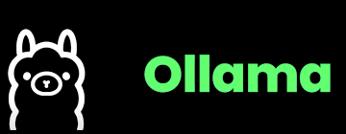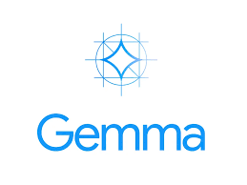

References
- GeeksforGeeks. (2024, June 3). Ollama explained transforming AI accessibility and language processing. GeeksforGeeks.
- Ollama. (n.d.). GitHub - ollama/ollama: Get up and running with Llama 3.1, Mistral, Gemma 2, and other large language models. GitHub.
- Ollama. (n.d.). Ollama.
- Banks, J. (2024, February 28). Gemma: Introducing new state-of-the-art open models. Google.
- Team, G., & Deepmind, G. (n.d.). Gemma 2: Improving Open Language Models at a Practical Size. Retrieved August 18, 2024, from https://storage.googleapis.com/deepmind-media/gemma/gemma-2-report.pdf
- Google | Gemma 2 | Kaggle. (2024). Kaggle.com.
- AXIOS Getting started | Axios Docs. (n.d.).

Key Concepts and Tools for Experiencing LLM Chat

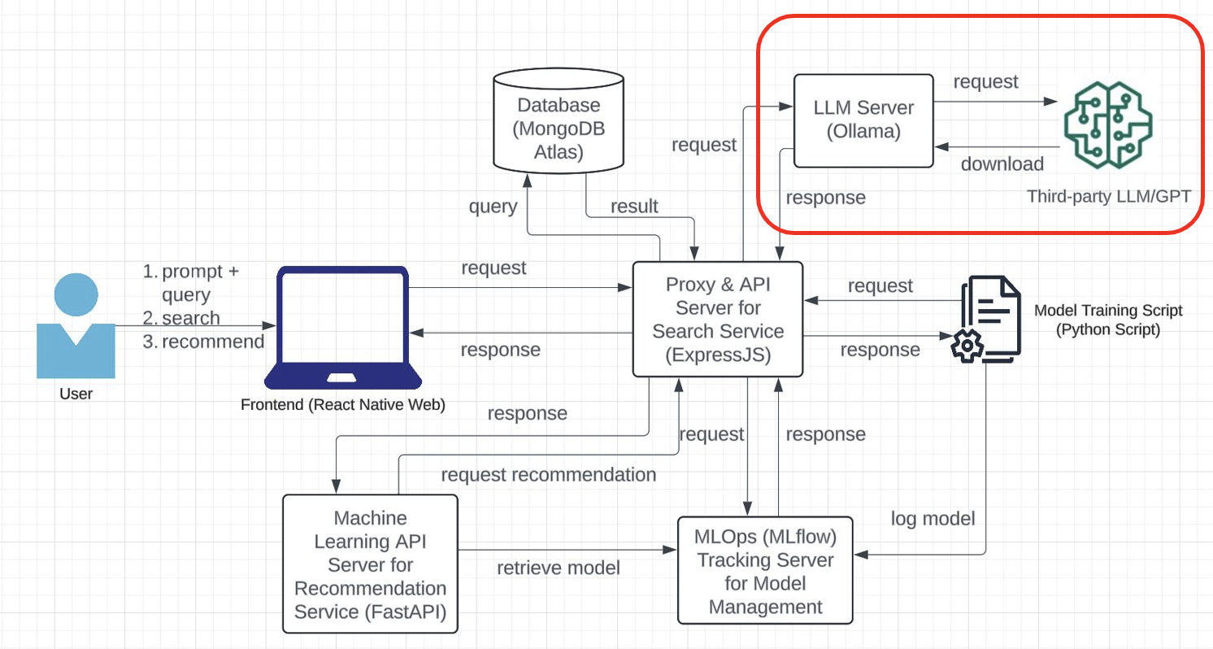

LLM Server (Ollama)
Ollama, which Jeffrey Morgan and Michael Chiang developed, stands for Omni-layer Learning Language Acquisition Model. In the diagram, the LLM Server (Ollama) section handles requests related to the language model (LLM) operations, particularly for the chat interface in the frontend.

- Frontend Interaction:
- The user interacts with the chat interface in the React Native web frontend, sending prompts or queries.
- These prompts are sent as requests to the LLM Server (Ollama) via the Proxy & API Server (ExpressJS).
- LLM Server (Ollama):
- The LLM Server (Ollama) receives and processes these requests using a third-party language model, such as a Generative Pre-trained Transformer (GPT).
- The LLM Server might either directly request the third-party LLM/GPT service or use a locally downloaded model to generate responses.
- Streaming Response:
- The LLM Server is configured to send streaming responses back to the frontend. This means that as the LLM generates a response, it starts sending it back immediately rather than waiting for the entire response to be ready. It creates a smoother, real-time chat experience for the user.
- Communication Flow:
- The processed response from the LLM Server (Ollama) is then sent back to the Proxy & API Server (ExpressJS).
- The ExpressJS server forwards the response to the React Native frontend, which is displayed in the chat interface.

- Third-party LLM/GPT:
- The third-party LLM/GPT (outlined in the red box) could be a service like OpenAI's GPT-3 or another similar model. It is the engine that generates the natural language responses based on the user's input.

Why Ollama?
Ollama is used for its advanced ability to understand and generate human-like text, enabling various applications from automation to educational support. Using advanced language models like those from OpenAI can streamline research by automating literature reviews, enhancing data analysis, and aiding in writing complex academic papers.

ExpressJS as Proxy Server and API Gateway
To streamline frontend requests to various services, we restructured our architecture so that ExpressJS serves as the sole service endpoint. ExpressJS will forward requests to different services, including the database, machine learning API server, MLOps tracking server, and LLM server. As with any system design, it is essential to consider and discuss the pros and cons of the architecture or design.

Pros:
- Simplified Frontend: A single endpoint (ExpressJS) reduces complexity in the frontend, making it easier to manage.
- Centralized Routing: ExpressJS handles routing, providing a single control point for directing traffic to the appropriate services.
- Scalability: The architecture can scale by managing different services behind the scenes, allowing independent scaling of backend components.
- Security: It is easier to enforce security measures like authentication and rate limiting at a single entry point.

Cons:
- Single Point of Failure: If ExpressJS fails, the entire system can be affected.
- Increased Latency: Routing requests through ExpressJS adds an extra layer, potentially increasing response times.
- Bottleneck Risk: High traffic could overwhelm ExpressJS, causing a bottleneck if not properly scaled.
- Complexity in ExpressJS: The service might become complex and more challenging to maintain as it takes on more responsibilities.

LLM with Gemma Model
Gemma is a family of lightweight, advanced open models developed by Google DeepMind, building on the research and technology behind the Gemini models. Named after the Latin word for "precious stone," Gemma models are designed for easy integration into applications, mobile devices, or hosted services. They can be customized using tuning techniques to excel at specific tasks. Supported by developer tools that encourage innovation and responsible AI use, Gemma models are intended for the AI development community to extend and enhance.

Gemma 2 and Gemma are key models in the Gemma family, designed for generative AI tasks like text generation, question answering, summarization, and reasoning. Built on the same research as the Gemini models, these base models come in various sizes, ranging from 2 billion to 27 billion parameters, and can be tuned for specific use cases.
What are the parameters in the context of machine learning and deep learning?
Parameters refer to the components within a model learned from the training data. These parameters are essential for the model's ability to make predictions or generate outputs based on new inputs.

- Weights and Biases: In neural networks, parameters typically include weights and biases. Weights are the values that determine the strength of the connections between neurons in different layers of the network, while biases are additional constants added to the inputs of a layer to shift the activation function.
- Training Process: During training, the model adjusts these parameters to minimize the difference between its predictions and the actual target values (the loss). This process is typically done using optimization algorithms like gradient descent.
- Model Size: The number of parameters in a model often corresponds to its complexity and capacity to learn intricate patterns. For example, larger models with billions of parameters can capture more detailed relationships in the data, but they also require more computational resources and may need larger datasets to train effectively.

Inputs and outputs
Input: A text string, such as a question, a prompt, or a document to be summarized.
Output: Generated English-language text in response to the input, such as an answer to a question or a summary of a document.

Model Data
Data used for model training and how the data was processed.

Training Dataset
These models were trained on a dataset of text data that includes a wide variety of sources. The 27B model was trained with 13 trillion tokens, the 9B model was trained with 8 trillion tokens, and the 2B model was trained with 2 trillion tokens. Here are the key components:

- Web Documents: A diverse collection of web text ensures the model is exposed to a broad range of linguistic styles, topics, and vocabulary. Primarily English-language content.
- Code: Exposing the model to code helps it learn the syntax and patterns of programming languages, which improves its ability to generate code or understand code-related questions.
- Mathematics: Training on mathematical text helps the model learn logical reasoning and symbolic representation and address mathematical queries.

The combination of these diverse data sources is crucial for training a powerful language model that can handle a wide variety of different tasks and text formats.

Data Preprocessing
Here are the key data cleaning and filtering methods applied to the training data:

- CSAM Filtering: Rigorous CSAM (Child Sexual Abuse Material) filtering was applied at multiple stages in the data preparation process to ensure the exclusion of harmful and illegal content.
- Sensitive Data Filtering: As part of making Gemma pre-trained models safe and reliable, automated techniques were used to filter out certain personal information and other sensitive data from training sets.
- Additional methods: Filtering based on content quality and safety in line with our policies.

Benefits
At the time of release, this family of models provides high-performance, open large language model implementations designed from the ground up for Responsible AI development compared to similarly sized models.

Using the benchmark evaluation metrics described in this document, these models have shown to provide superior performance to other, comparably sized open model alternatives.

Uploading three image files to your GitHub Repository generated from GitHub Classroom
- The screenshot of your ‘OLLAMA LLM SERVER’ as ‘firstname_lastname_ollama_llm_server.png.’
- The screenshot of your ‘CHAT RECOMMEND’ as ‘firstname_lastname_chat_recommend.png.’

Use Case
As a movie enthusiast using a mobile device, I want to search and browse a list of movies with details such as title, genre, and year to quickly find information about movies I am interested in while on the go.

As a movie enthusiast using a mobile device, I want to get movie recommendations from my selections.

As a movie enthusiast using a mobile device, I want to chat and get movie recommendations from my selections.

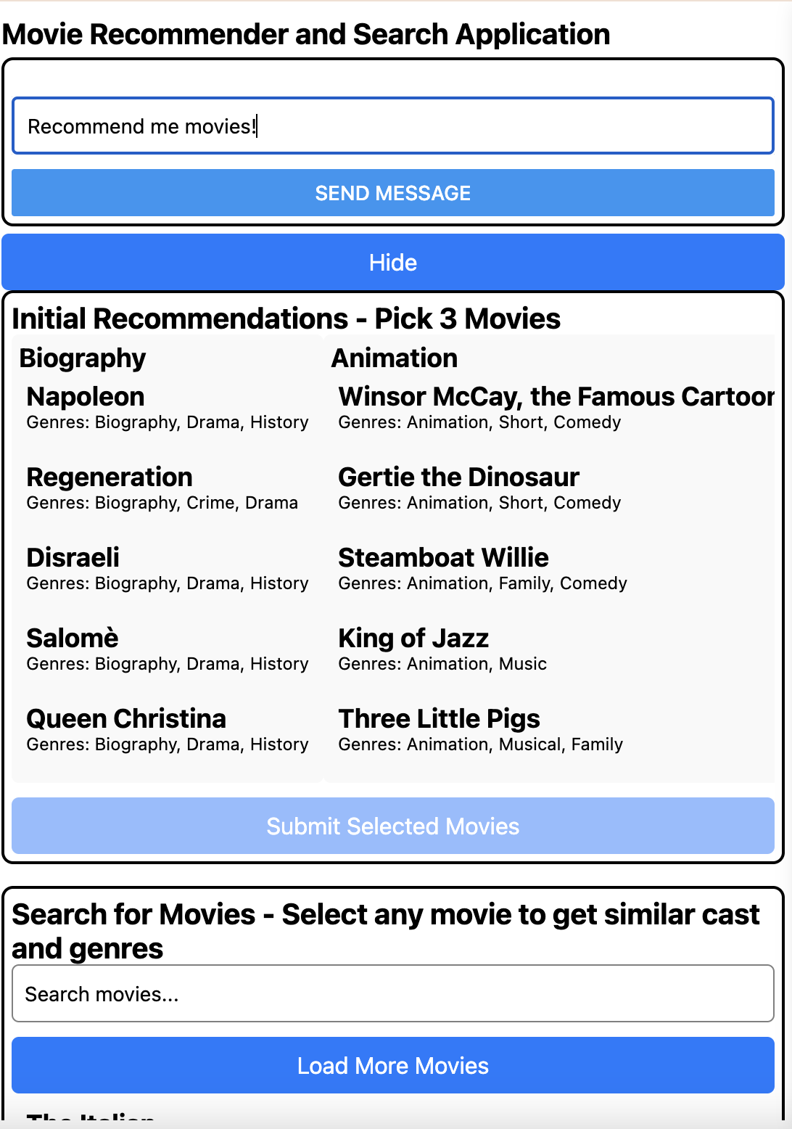

Features included:
- Chat Recommendation
- Movie List Display
- Search Functionality
- Initial Recommendations
- New Recommendations
- Similar Cast and Genres

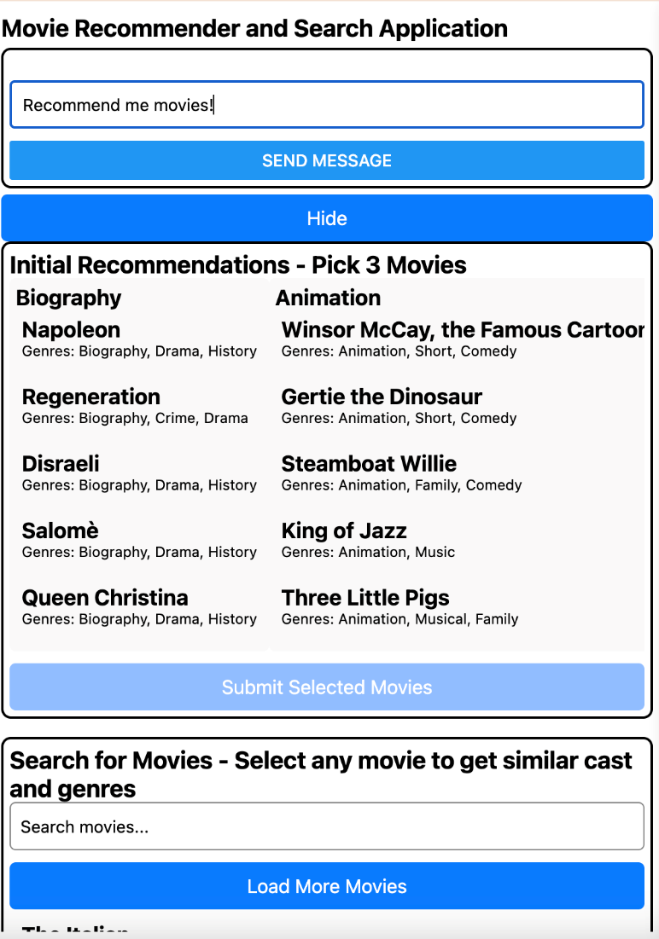

Setup

2.1) Running the Ollama LLM Server
- Create/Open GitHub Codespaces.
- Open a terminal and type the following:
  - curl -fsSL https://ollama.com/install.sh | sh
The command curl -fsSL https://ollama.com/install.sh | sh is used to download and execute a shell script from the specified URL. This specific script is designed to install Ollama on a Linux system. It detects the operating system architecture and installs the appropriate version of Ollama. The script also handles setup tasks, such as creating necessary directories and setting permissions.
    - curl: This is a command-line tool for transferring data with URLs.
    - -f: This option tells curl to fail silently when there are server errors.
    - -s: This makes curl operate silently without showing progress or error messages.
    - -S: When used with -s, it makes curl show an error message if it fails.
    - -L: This option tells curl to follow redirects.
    - https://ollama.com/install.sh: This is the URL of the script you want to download.
    - | sh: This pipes the downloaded script to the sh command, which executes it.
  - ollama serve
This command will start the server, and you can then interact with it using the Ollama API or other tools that communicate with the server.
- Test the Forwarded Address in the Browser. You can find the URL (port number: 11434) from the “PORTS” tab.

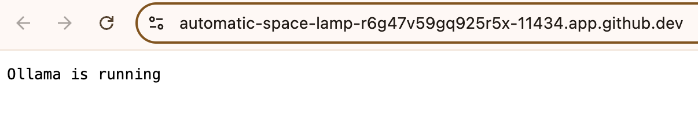

- Open a terminal and type the following:
  - ollama pull gemma2:2b
This command will download the Gemma 2 model with 2 billion parameters to your local environment, making it ready for use.
  - ollama run gemma2:2b
This command will start the Gemma 2 model, making it ready for inference tasks.
Note: if you are experiencing not enough memory. Use tinyllama as an alternative.

Let's delete the model first:
ollama rm gemma2:2b

ollama pull tinyllama

Then update the codebase to use tinyllama

Gemma is a family of lightweight, state-of-the-art open models developed by Google. These models are designed for responsible AI development and are built from the same research and technology used to create the Gemini models

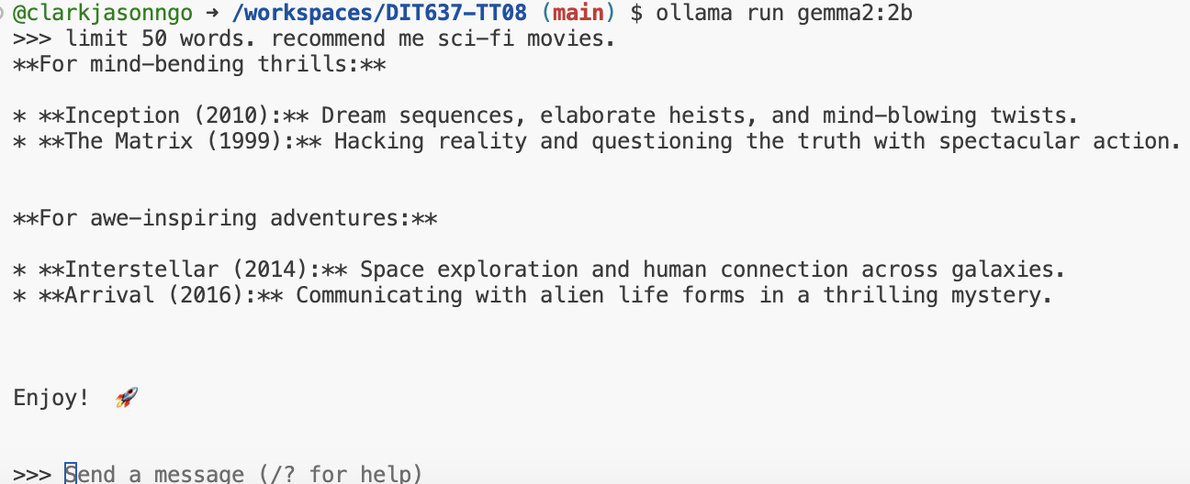

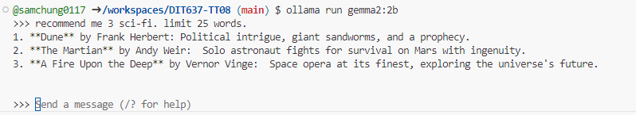

Take a screenshot of your ‘OLLAMA LLM SERVER’ as ‘firstname_lastname_ollama_llm_server.png’.

- To exit the chat, press:
  - CTRL + D

2.2) Running the Backend ExpressJS Application Server
- Create a .env file inside ‘backend-expressjs’ folder (use example.env file as a reference)
  - Update the MONGODB_URI= connection string
- Open a new terminal:
  - cd backend-expressjs
  - npm install
  - npm run start
- Make the Port Public
- Copy the Forwarded Address (URL)
- Do a quick test if its running (append /movies to the URL)

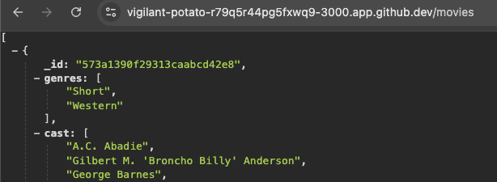

2.3) Running the MLflow Tracking Server
- Open a terminal and type the following:
  - cd mlops_mlflow
  - pip install -r requirements.txt
pip reads the “requirements.txt” file and installs all the listed packages with the specified versions
  - mlflow server
- Test the Forwarded Address in the Browser
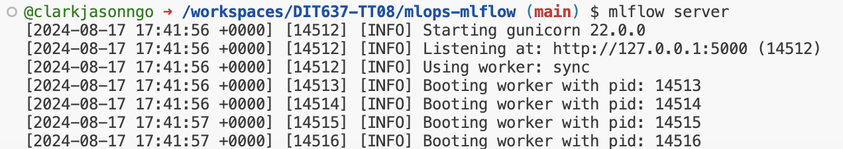

Access the MLflow Tracking Server
- Click the 127.0.0.1:5000 in the output (or access this in the Ports tab)
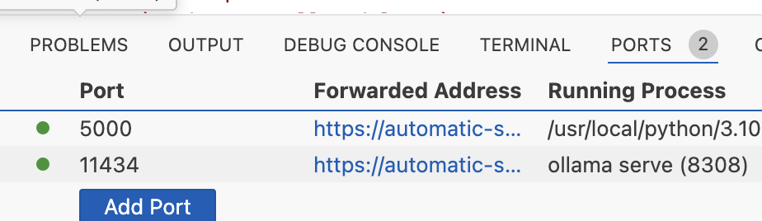

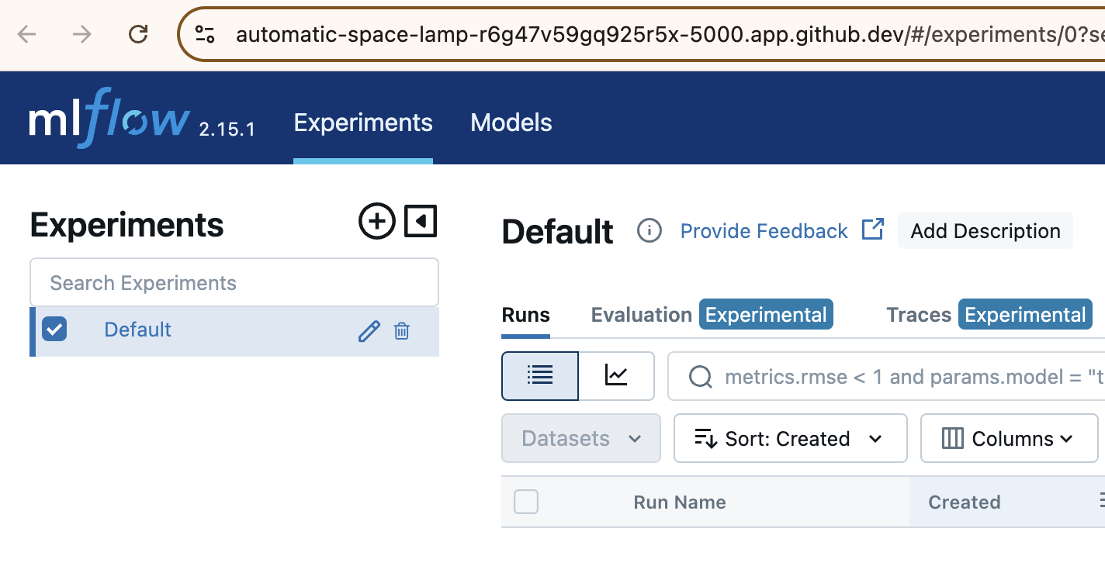

2.4) Running the Python Scripts for ML Model Deployment (under the ‘mlops-mlflow’ directory)

Train different model and prepare metadata for logging
- Open a new terminal:
  - cd mlops-mlflow
  - python run_all_models.py
- New folders ‘mlartifacts’ and ‘mlruns’ and their respective files will be generated and will be used as data in the MLflow Tracking Server.
  - ML Artifacts: Data files, models, and code created during machine learning experiments, stored for reproducibility, tracking, and reuse in future projects.
  - ML Runs: Individual executions of machine learning experiments, including configurations, parameters, and results, tracked to compare and improve models.

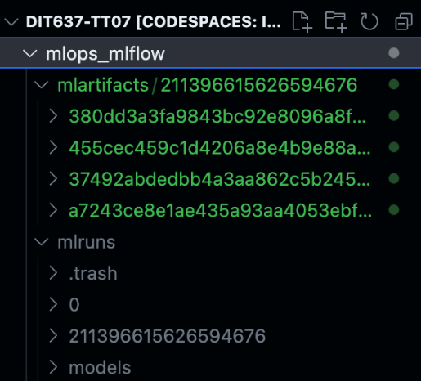

View the Experiments in the MLflow Tracking Server
- Head back to the server by clicking the Forwarded Address in the Ports tab.
- Tick the checkbox for Movie Genre Prediction to view all 4 models that were run.

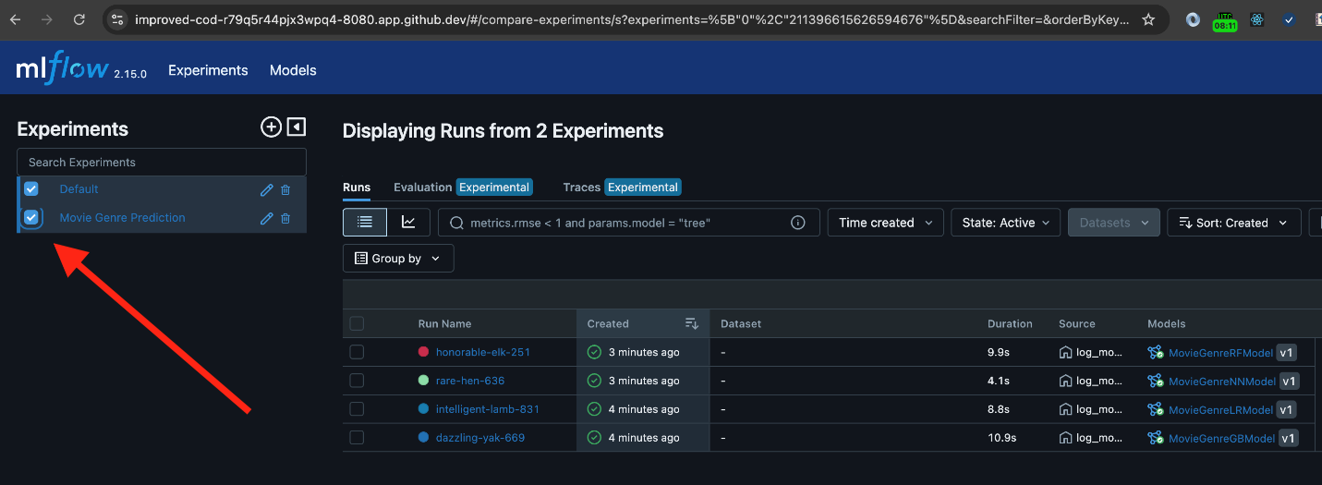

For example,

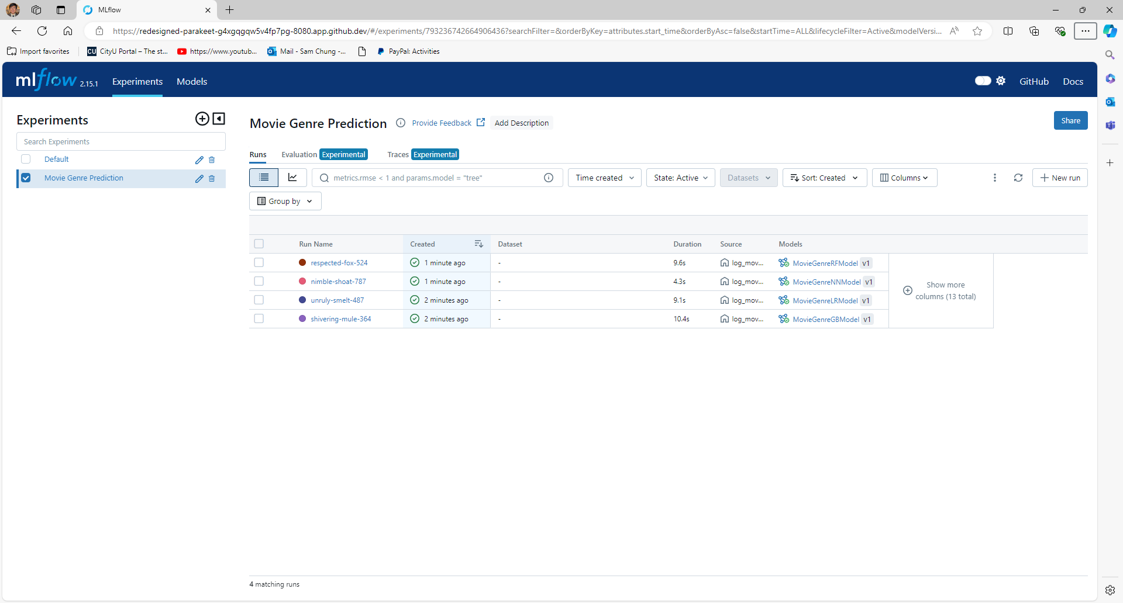

2.5) Running the Machine Learning Model FastAPI Server
- Open a new terminal:
  - cd modelserver-fastapi
  - pip install –r requirements.txt
  - uvicorn main:app --reload
The ‘uvicorn main:app –reload’ is used to start a FastAPI application with Uvicorn, an ASGI (Asynchronous Server Gateway Interface) server.
- Copy the Forwarded Address (URL)
- Do a quick test if its running

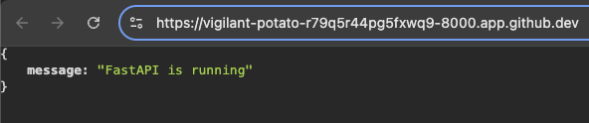

2.6) Running the Frontend React Native Mobile/Web
- Create a .env file inside ‘frontend-reactnative’ folder (use the ‘example.env’ file as a reference)
  - Update the API_URL= with ExpressJS Forwarded Address
  - Please be mindful to NOT include a “/” at the end

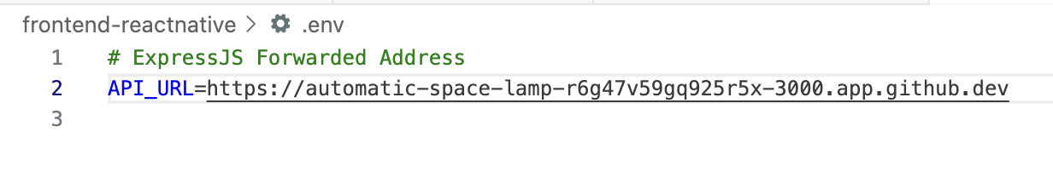
- Open a new terminal:
  - cd frontend-reactnative
  - npm install
  - npx expo start --web (or if mobile: npx expo start --tunnel)

If you encounter some loading issues, try:
  - npx expo start --web --clear (or if mobile: npx expo start --tunnel --clear)

If not working In GitHub Codespaces, use this command: CI=1 npx expo start --tunnel --clear

- Open the Forwarded Address.

If you encounter a CORS error, please restart your ExpressJS server.
The chat feature might encounter some errors on mobile devices, please use the mobile web

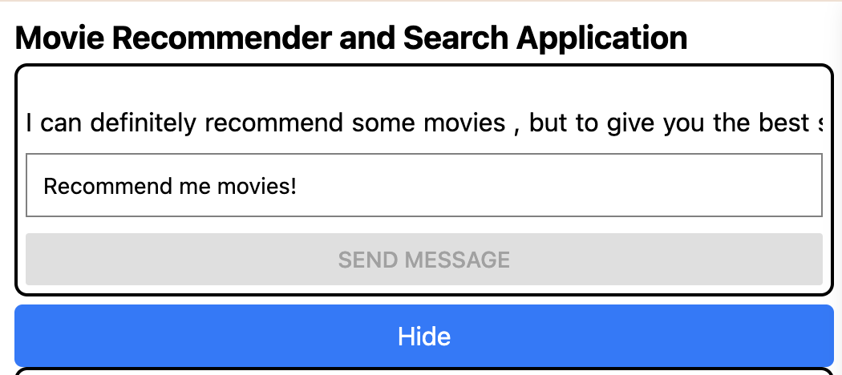

- Try to chat and send messages (wait for the reply – above the messageBox). For example:
  - “Recommend me 3 Romantic Movies.”
- Take a screenshot of your ‘CHAT RECOMMEND’ as ‘firstname_lastname_chat_recommend.png’.

Screenshot Summary
Chat: test the chat with any prompt. For example: "Recommend me 3 comedy movies".

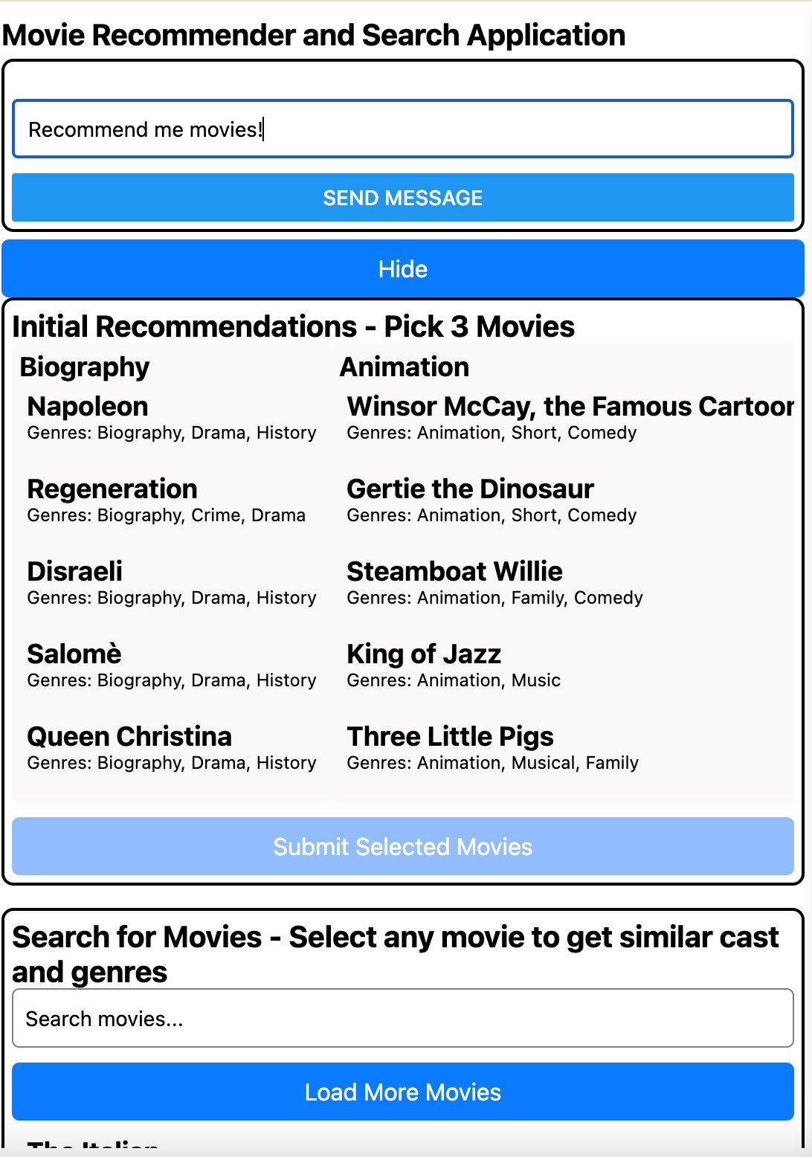

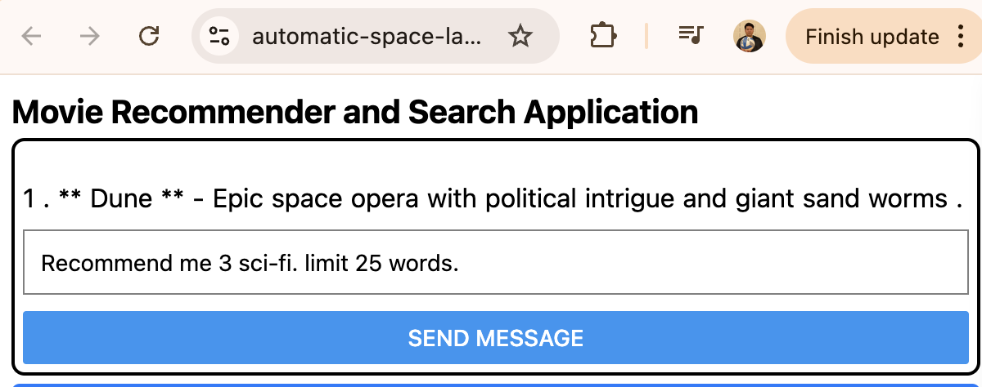

Code Breakdown – Changes in ExpressJS as Proxy Server & API Server

FastAPI Communication Function
- fetchFromFastAPI: Sends POST requests to the FastAPI server and returns the response. Handles errors if the request fails.

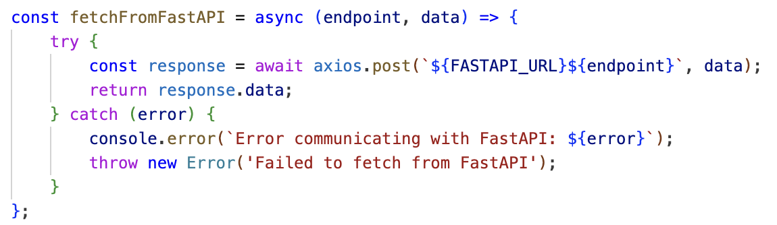

Axios is a promise-based HTTP Client for node.js and the browser. It is isomorphic (= it can run in the browser and nodejs with the same codebase). On the server-side it uses the native node.js http module, while on the client (browser) it uses XMLHttpRequests.

Routes
/chat (POST): Handles chat interactions, forwarding requests to the Ollama server and streaming the response back to the client in real-time.

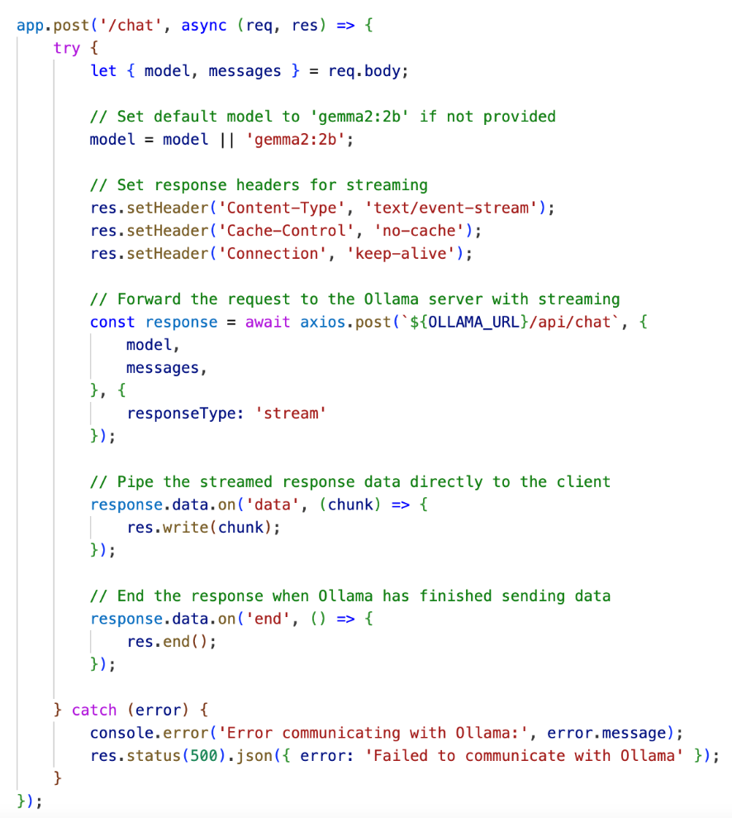

Code Breakdown – Frontend React Native Chat

Chat Function
The handleChat function is responsible for sending a chat request to a server and processing the streamed response in a React application. Here's a breakdown of what it does:

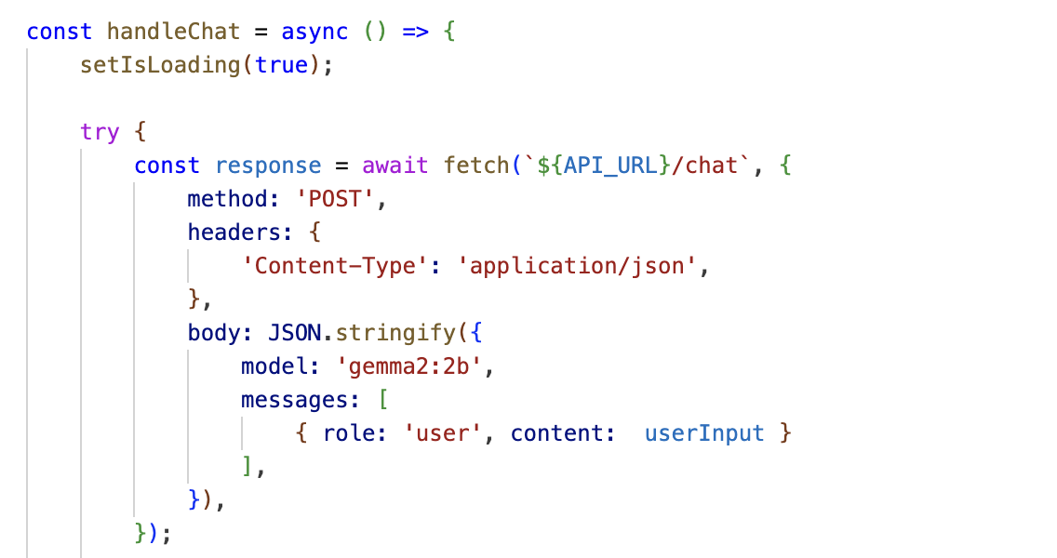

The code snippet you provided is an asynchronous function named handleChat. This function is designed to send a POST request to a server endpoint to handle chat messages. This function helps send chat messages to a server that processes them using the specified model (gemma2:2b).

Decode: The chunk of binary data (value) is decoded into a string.

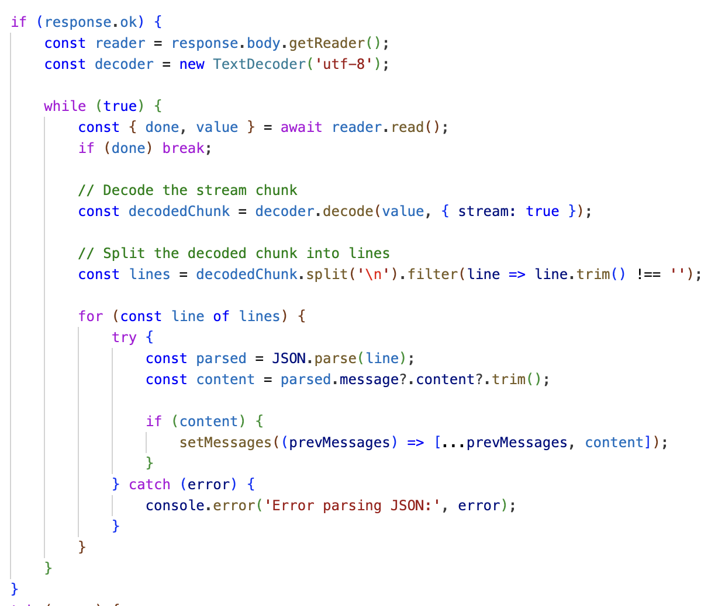
What is Streaming and Chunking?

Streaming delivers data in small, manageable pieces (chunks) as it's produced, rather than waiting for the entire data set.

Streaming, a process of continuous data transmission from a source to a destination, offers real-time benefits. It allows data to be processed and consumed as it arrives, making it particularly engaging for applications like video streaming, live broadcasts, and online gaming.

Chunking is a data transfer method in which the data stream is divided into smaller, manageable pieces called “chunks.” Each chunk is preceded by its size in bytes, and the transmission ends when a zero-length chunk is received. This method is particularly useful when the content length is not known beforehand.

This allows immediate processing and display of information, reducing latency and memory usage, especially useful for large files or real-time data like video, audio, or continuous text responses.

The code creates a chat interface using React Native components.
- It includes a View container with a FlatList to display chat messages. The list is rendered horizontally, with a separator between items.
- A TextInput allows users to type their messages, and a Button sends the message when pressed.
- The FlatList uses index as a key for simplicity, and the Button is disabled while loading.

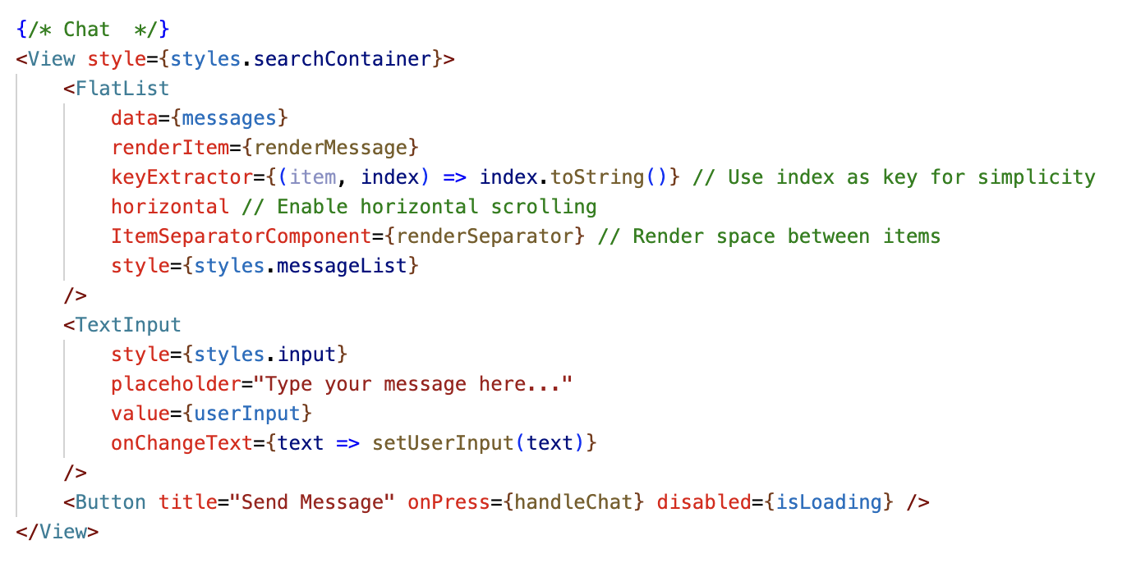

AI-Assisted Documentation
Objective: Use Generative AI to help you articulate the architectural changes and key concepts you implemented in this lab.
Instructions:
- Select a Key Snippet: Identify the most important code you modified in this lab.
- Prompt an AI: Use a Large Language Model (e.g., Gemini or ChatGPT) with the following prompt:
"I am a student completing a technical lab on [Insert Lab Title]. I have implemented [Insert Feature] using [Insert Tool].
Based on this code snippet: [Paste your code here]
Please write a concise, professional 3-sentence summary for my GitHub README that explains the architectural role of this code and how it contributes to a 'Smart and Secure System'."
- Update your README: Review the AI-generated explanation, edit for accuracy, and paste it into your repository's README.md.

Document | [Insert Lab Title] | [Insert Feature] | [Insert Tool]
TT08 | LLM Chat | a local AI chat interface | Ollama and the Gemma model

Pushing your work to GitHub
  - Go to Source Control on your GitHub codespaces and observe the pending changes.
  - Type the Message for your changes in the Message box on the top. For example,” Submission for TT08 – Your Name”
  - Click on the dropdown beside the commit button and select Commit & Push to update the changes to your repository main branch.
  - Select Yes when prompted.

